Project Report

|  |  |
| --- | --- |
| Product Name | Develop an Online Registration form for a Training Institution |
| Qualification Name (NICF) |  |
| Product Name | Programming Foundations |
| Module Name (NICF) | **ITSF Programming Foundations** |

|  |  |  |  |
| --- | --- | --- | --- |
| Student name | | Assessor name | |
| Joshua Ho Gwok Hin | |  | |
| Date issued | Completion date | | Submitted on |
| 10/01/2022 | 17/01/2022 | | 17/01/2022 |
|  | |  | |
| Project title | Develop an Online Registration form for a Training Institution | | |

|  |
| --- |
| Learner declaration |
| I certify that the work submitted for this assignment is my own and research sources are fully acknowledged.  Student signature: Date: 17/01/2022 |

Content

1. Project background
2. Project Objectives
3. Task 1: Requirements Specifications for the Project Scenario.
4. Task 5: Design document for the Proposed System based on Requirements Specification
5. Task 7: Write code to save the form values in database and show a thank you screen.
6. **Project Background**

**ABC Learning Center** intends to capture student details at the time of enrolment in an online application developed in JSP and MySQL.

To achieve the expectations of the training institute’s request, we will be doing the following:

1. To **design a registration form** so that student details can be captured.
2. The information entered will be first **validated** before posting to the server
3. The posted data will be **saved to MySQL RDBMS**
4. Prepare **Test Planning and Execution Script for UAT**
5. Technical document and user manual

Target project result:

With implementation of an **Online Student Registration Form** developed in JSP and MySQL, the company can now allow users to register for courses made **available by admin**. This enabled the training institution to capture student details, and also enhancing productivity by reducing possible confusion over outdated offers.

1. **Project Objective**

Goals

* + Business goals
    - To allow course registration for available courses on the website → Students can only register for available courses → To improve overall productivity
  + User goals
    - To be able to select the available courses and register.
    - Improve user experience with updated database to be populated in the registration form.
  + Project Team goals
    - To implement the Student Registration Form for ABC training center using HTML, JavaScript and JSP. Test the registration form before releasing to users as per Test Scripts

1. **Requirement Specification for the Project Scenario**

Scope of the project

* Display the available courses to be selected during registration.
* Design and build a functional Student Registration Form
* Save the collected date to Database.

Functional requirements

<http://localhost:8080/WebContents/register.jsp>

* Student Registration Form Fields
  + First Name
  + Last name
  + Gender
  + Residential Address
  + Phone Number
  + List of Courses
* First Name is a **Mandatory Field of Alphabets only**
* Last Name
* Gender with 2 options, male & female.
* Residential is a **<textarea>** field
* Phone Number is a numeric field with a max of 11 characters
* List of Courses to be fetched from Database and populated as a selectable dropdown
* Thank You Page (nested in student_action.jsp <%@ include file="**thankyou.html**" %>)

Non-functional requirements

* Browsers Supported – Chrome 95, Edge 94, Firefox 93, Safari 15
* User friendliness/user interface/usability – Conduct monthly testing with test scripts.
* Loading time – 200ms
* Availability – Visit the website on every Monday before 10am or the next working day if it falls on a non-working day.
* Check for broken links using online tools during availability checks.

Technical requirements (software and hardware)

* Software: Platform needed to deploy the application n (tomcat server and its version, java and its version)
  + Development environment: JDK1.8
  + Tomcat 9
  + Editor: Intellj
  + Programming languages: Java
* Hardware: client server (windows/mac system)
  + Client (User) – Windows– Windows 11
  + Server (Hosting Environment) – Windows Server

1. **Design document for the Proposed System based on Requirements Specification.**

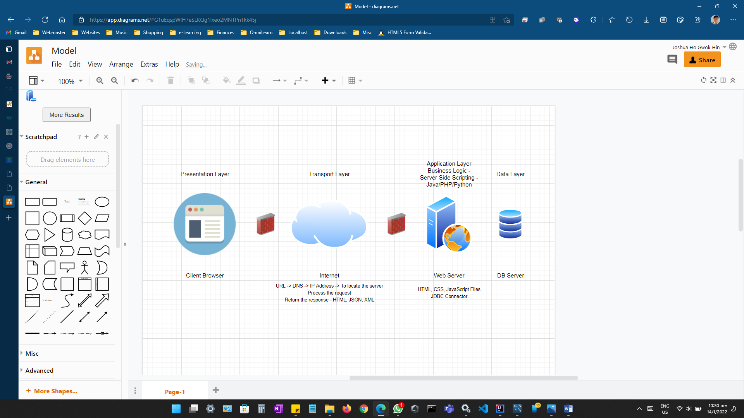

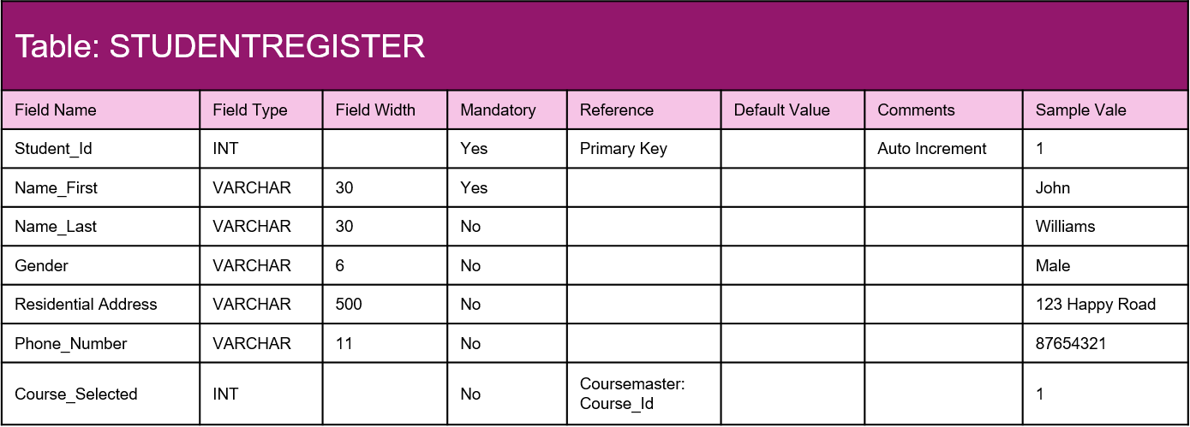MySQL Data Dictionary

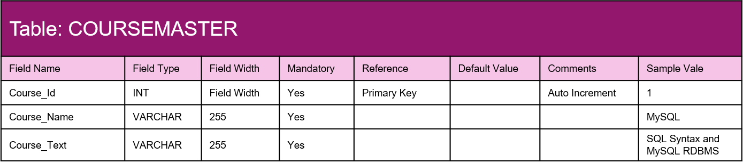

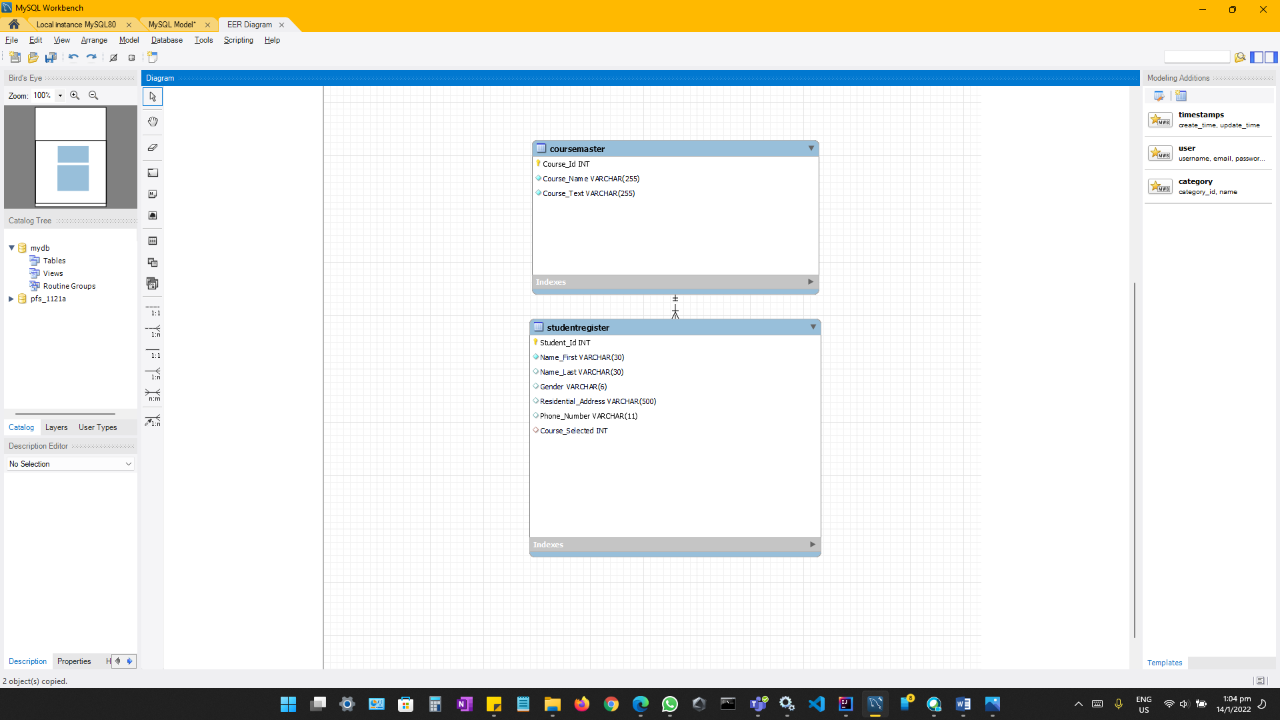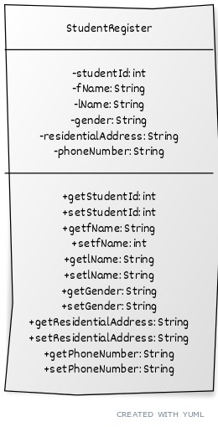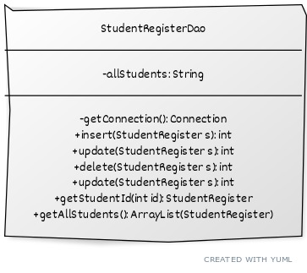



1. **Write code to save the form values in database and show a thank you screen.**

